Use of Information Resources and Services of District Library, Kurukshetra, Haryana: A Study
Times New Roman, 11, Centered, only name of the author is bold

Naresh Kumar¹, Research Scholar
Department of Library & Information Science,
Times New Roman, 22, Bold, Centered
Kurukshetra University Kurukshetra
E mail: reach4naresh@gmail.com¹

Abstract
Times New roman, 12, Bold, Left
Times New roman, 12, Bold, Left
Times New roman, 12, Bold, Left
Times New roman, 12, Bold, Left
Times New roman, 12, Bold, Left
The main purpose of this paper was to take view from the users of District Library, Kurukshetra (Haryana), India with regard to use of resources and services. A Questionnaire based survey was conducted to identify the satisfaction level of users with library resources and services. For the purpose, a total of 100 questionnaires were distributed and 82 valid responses were received. It has been concluded that the overall professionals/Businessmen have more perception score i.e. mean = 3.1945. Govt. should support for ICT infrastructure to enrich the library services and efforts should be made to get the Haryana Public Library Act implemented in toto.
Times 12, Bold, Left
Key Words: Public Library, User Satisfaction, State Central Library, Library Services
Times New roman, 10, Normal
Times New roman, 10, Normal
Introduction
It has been accepted world-wide that libraries provide pedestal for transforming the lives through its various educational resources and services. To this view, public libraries have contributed well and continually trying to perform better than before to transform the culture. With the growth in education, literacy and publication, public libraries arose worldwide. Every country has its own public library history and India is no exception. However, in 1957, an Advisory Committee for libraries was constituted by Government of India to report on the status of Public Libraries Development and in 1972, another worthwhile step was taken by Central Govt. by establishing the RRRLF (Raja Ram Mohun Roy Library Foundation) with the aim of developing the libraries in general and Rural Library Development in particular.
Times New roman, 10, Justified
In 2005, NKC (National Knowledge Commission) was also established. Its chief recommendations with regard to libraries were to rejuvenate the existing public libraries and new libraries to be established as centers of excellence. In pursuance of the recommendations of NKC in 2012 a project namely ‘National Mission on Libraries’ was constituted.
Public libraries all over the world are struggling to find a new, unique and vital source of value. ICT and internet technologies have changed the nature of libraries in all sectors, and they have also changed the perception and expectations of the user community (Chowdhary, 2006).
The next opportunity is to create ‘a different library that is not a copy of the existing library; a parallel library of content, services and facilities that can only be delivered on the web or that are best delivered on the web is ‘cultural Change’ (Alden, 2006).
To perform better in challenging environment and to keep up with pace transformations, it is worthwhile to know the structure, functioning and services provided by the Public Libraries in the present scenario. Hence, the present study ‘Use of Information Resources and Services of District Library, Kurukshetra, Haryana: A Study’ was selected.
Before exploring the structure, functioning and services provided by the Public Libraries, it is important to consider some definitions of public libraries.
“A public library is an entity that is established under state enabling laws or regulators to serve a community, district, or region, and that provides at least the following: 1) an organized collection of printed or other library materials, or a combination thereof; 2) paid staff; 3) an established schedule in which services of the staff are available to the public; 4) the facilities necessary to support such a collection, staff, and schedule; and 5) is supported in whole or in part with public funds”.-(CPLA)
“A public library is a library that is accessible by the general public and is generally funded from public sources, such as taxes. It is operated by librarians and library paraprofessionals, who are also civil servants”. –(Wikipedia)
About District Library, Kurukshetra (Haryana), India
It was established in 1985 and having a rich collection of 29711 books besides this, library subscribes 12 newspapers and 55 current magazines of different interests. For better arrangement of books; DDC-19th ed. and Cataloguing Code AACR-2 have been adopted. Library gives service of OPAC (Online Public Access Catalogue) which enrich the performance of searching the collection.
The library has 2881 registered members and remains open from 10:00 AM to 5:00 PM on all days except Fridays, Gazetted Holidays and last Saturday of every month.
The District Library, Kurukshetra is administered by Directorate of Higher Education, Haryana. The main services/ facilities being provided are: Circulation, OPAC, Reservation of Books and Reference Service, Reading Hall, Public Meeting Room and Drinking Water, Parking etc.
Times New roman, 12, Bold, centered, space 12pt before and after
Times New roman, 12, Bold, centered, space 12pt before and after
Budget of District Library, Kurukshetra
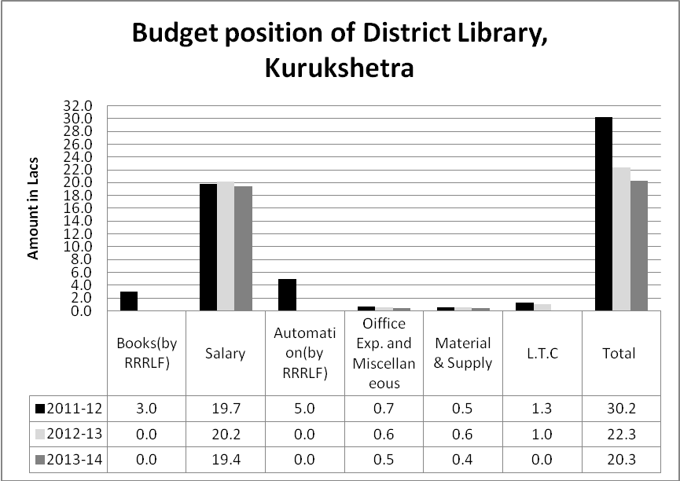
Times New roman, 12, Bold, Left
Objectives of the study
The objectives of the study are to:
- Find out if there is any significant difference among different type of users with regard to frequency of visiting.
- Know the purposes for which users’ use the public library.
- Examine if there is any significant difference in degree of satisfaction among the different type of users with regard to collection.
- Examine if there is any significant difference in degree of satisfaction among the different type of users with regard to infrastructure
- Examine if there is any significant difference in degree of satisfaction among the different type of users with regard to staff.
- Examine if there is any significant difference in degree of satisfaction among the different type of users with regard to facilities and services.
- Examine if there is any significant difference in degree of satisfaction among the different type of users with regard to overall infrastructure, staff, facilities and services.
Times New roman, 12, Bold, Left
Hypotheses of the study
Hypotheses of this study are:
- There is no significant difference among different type of users with regard to library visits.
- There is no significant difference among different type of users with regard to purpose of visiting the library.
- There is no significant difference in degree of satisfaction among the different type of users with regard to collection.
- There is no significant difference in degree of satisfaction among the different type of users with regard to Infrastructure.
Times New roman, 10, Justified
- There is no significant difference in degree of satisfaction among the different type of users with regard to staff.
- There is no significant difference in degree of satisfaction among the different type of users with regard to facilities and services.
- There is no significant difference in degree of satisfaction among the different type of users with regards to overall Infrastructure, Staff, facilities and Services of the District Library, Kurukshetra.
Review of literature
Yuvaraj and Maurya (2014) carried out a study entitled “Public libraries in Varanasi (Uttar Pradesh), India: An Explorative Study” with the core purpose to explore the current status of public libraries of Varanasi. Study shows that even today public libraries lag behind in providing their basic services and the libraries under study lack basic amenities which are lying in a dilapidated state. The government should ensure monetary support along with necessary infrastructure which may enable the libraries to provide their services in best possible manner.
Kumar and Naik (2014) conducted a study entitled “Use pattern of information resources by citizens in public library: A case study of District Central Library, Tumkur (Karnataka)”. The aim of the study was to identify the satisfaction level of citizens with regard to the library resources and services. keeping in view, the opinions of the users and the analysis; study recommends that library should purchase multiple copies of the classic books as per interest of the users; user education progrrames should be organized and special additional budget should be allocated to enhance the library collection.
Velmurugan (2013) conducted a survey on Use of library sources and services of Virudhunagar District Central Library. The main objectives of the survey were to analyze the membership pattern, various physical facilities available to the users, evaluate use of various sources of information and services available in the library and, to study opinion about the library collection and satisfaction of reference system available in the Virudhunagar Dsitrict Library. The Study recommends developing digitized collections services and knowledge, improved accessibility of catalogues and databases especially for users with visual impairments.
Thanuskodi (2013) conducted an intensive study entitled “Assessing the Efficacy of Library Services of District Central Libraries in Tamil Nadu from Users Perception”. The objectives of the study was to assess the existing state of affairs of the library in respect of its services, facilities and general satisfaction of the users regarding the library services. The study concluded that district central libraries are lagging behind particularly in providing user-specific information. It is thus imperative that they must redesign their approach.
Iwhiwhu and Okorodudu (2012) conducted a survey entitled “Public Library Information Resources, Facilities, and Services: User Satisfaction with the Edo State Central Library, Benin-City, Nigeria”. The main aim of the survey was to know the satisfaction level of the users with regard to information sources and services available in the central state library so that services may be improved more. This study recommended that the state government should provide the necessary funds to stock the library with relevant information resources and ICT facilities for effective functioning of the Edo State Central Library; In addition, the operations of the library should be automated to enhance library services provided by the library.
Chowdhury, Poulter and McMenemy (2006) conducted a study entitled “At the sharp end Public Library 2.0: Towards a new mission for public libraries as a “network of community knowledge” with the purpose to propose a new vision for public libraries in the digital age. Study concluded that public libraries in the digital age should act as a platform facilitating the creation of, and access to local community knowledge within the global context. The study also proposed a model for PL2.0 where public libraries can play new role to establish a network of community knowledge.
SCOPE
Though there are number of libraries in Kurukshetra District, only District Library, Kurukshetra has been taken for the study because it is one of the oldest libraries, it is enrich in collection of books and subscribes great number of newspapers and current magazines. Large number of users avail the facilities and services being provided by library because of it has been located in center of the city. Survey method was adopted for the present study. A structured questionnaire was used to collect the data for users. A total of 100 questionnaires were distributed among different categories of users and 82 responses representing 82% were found valid for analysis. To analyze the data, Statistical techniques like mean, standard deviation, f-test and Chi square have been used with the help of statistical tool SPSS and Excel.
Times New roman, 12, Bold, centered, space 12pt before and after
DATA ANALYSES
Table 1 -STATUS OF USERS
Status of users  Times New roman, 10, Normal | Frequency | Percent
Student | 43 | 52.4
Housewives | 15 | 18.3
Professionals/Businessmen | 7 | 8.5
Retired | 5 | 6.1
Unemployed | 12 | 14.6
Total | 82 | 100.0
Table 1 shows the status of respondents. The highest numbers of users i.e. 52.4% are students followed by housewives (18.3%), unemployed (14.6%), retired (6.1%) and least number of users i.e. 8.5% are Professionals/Businessmen.

Table 2 – FREQUENCY OF LIBRARY VISITS OF USERS
Status | VISITOFTEN |  |  |  | Total | % | Chi Sqr.  7.749  P value  .804
 | Daily | Weekly | Fortnightly | Monthly
Student | 35 | 3 | 3 | 2 | 43 | 52.4
Housewives | 11 | 2 | 2 | 0 | 15 | 18.3
Professionals/ Businessmen | 5 | 2 | 0 | 0 | 7 | 8.5
Retired | 4 | 1 | 0 | 0 | 5 | 6.1
Unemployed | 9 | 2 | 0 | 1 | 12 | 14.6
Total | 64 | 10 | 5 | 3 | 82
% | 78.05 | 12.20 | 6.10 | 3.66 | 100

Table 2 shows that majority of the users i.e. 78.05% visit the library daily followed by 12.2% users visit weekly, 6.1% users visit fortnightly and least number of users i.e. 3.66% users visit the library monthly.
It has been found that all the users visit the library more frequently. The p value of chi square test for the frequency of visit is more than the critical value (.05) and the hypothesis 1 is accepted. Hence, there is no significant association among different type of users with regard to daily visit of the library.

Table 3- PURPOSE OF VISITING
Purposes | Not at All | Rarely | Sometime | Frequently | Always | Total | mean | std deviation | rank
Reading Magazine/Newspapers | 5 | 3 | 0 | 22 | 52 | 82 | 4.38 | 1.096 | 1
 | 6.1 | 3.7 | 0 | 26.8 | 63.4 | 100.0
Borrow/Return Books | 3 | 8 | 5 | 13 | 53 | 82 | 4.28 | 1.168 | 2
 | 3.7 | 9.8 | 6.1 | 15.9 | 64.6 | 100.0
Reading General Books/Course Books | 10 | 23 | 0 | 12 | 37 | 82 | 3.52 | 1.573 | 3
 | 12.2 | 28.0 | .0 | 14.6 | 45.1 | 100.0
Consult Reference material | 16 | 32 | 10 | 11 | 13 | 82 | 2.67 | 1.361 | 4
 | 19.5 | 39.0 | 12.2 | 13.4 | 15.9 | 100.0
Consult audio/ video material | 21 | 35 | 13 | 0 | 13 | 82 | 2.38 | 1.311 | 5
 | 25.6 | 42.7 | 15.9 | 0 | 15.9 | 100.0
Attend community meeting | 21 | 36 | 7 | 10 | 8 | 82 | 2.37 | 1.262 | 6
 | 25.6 | 43.9 | 8.5 | 12.2 | 9.8 | 100.0
Visit Exhibition | 29 | 33 | 9 | 8 | 3 | 82 | 2.06 | 1.093 | 7
 | 35.4 | 40.2 | 11.0 | 9.8 | 3.7 | 100.0
Access Internet | 82 | 0 | 0 | 0 | 0 | 0 | 1.00 | .000 | 8
 | 100.0 | .0 | 0 | .0 | .0 | .0
Use computer | 82 | 0 | 0 | 0 | 0 | 0 | 1.00 | .000 | 9
 | 100.0 | .0 | 0 | .0 | .0 | .0

Table 3 shows that majority of users always use library for reading ‘Magazines/Newspapers’, which has been ranked at Rank 1st with highest mean value (=4.38, σ=.1.096 ) followed by 'Borrow and Return the books' (2nd rank). The least number of users visit the library for Book Exhibition (rank 7th). ‘Access Internet’ and ‘Use of computer’ have been ranked 8th and 9th. It is pertinent to mention that these two facilities/services are not available in the library.
Table 3 (a)-MEAN DIFFERENCE OF USERS’ PERCEPTIONS WITH
REGARD TO PURPOSE OF VISITING THE LIBRARY
Occupation | N | Mean | Std. Deviation | F Value  5.328  P Value  .001
Student | 43 | 2.3275 | .46908
Housewives | 15 | 2.4833 | .45229
Professionals/Businessmen | 7 | 2.8810 | .36596
Retired | 5 | 2.6833 | .38370
Unemployed | 12 | 2.8750 | .37013
Total | 82 | 2.5051 | .48633

It has been observed from the above table 3(a) that there is significant difference in the purpose of visiting the library among different types of users because p value is less than the critical value (.05). Hence, the hypothesis 2 is rejected.

Table 4- SATISFACTION WITH COLLECTION

Collection | Very dissatisfied | Dissatisfied | No Opinion | Satisfied | Very Satisfied | Total | Mean | Std. Deviation | Rank
Newspapers | 0 | 0 | 2 | 18 | 62 | 82 | 4.73 | .498 | 1
 | .0 | .0 | 2.4 | 22.0 | 75.6 | 100.0
Current Magazines | 0 | 2 | 13 | 33 | 34 | 82 | 4.20 | .793 | 2
 | .0 | 2.4 | 15.9 | 40.2 | 41.5 | 100.0
General Books | 2 | 2 | 17 | 19 | 42 | 82 | 4.18 | 1.008 | 3
 | 2.4 | 2.4 | 20.7 | 23.2 | 51.2 | 100.0
Children Fiction Books | 3 | 3 | 26 | 27 | 23 | 82 | 3.78 | 1.019 | 4
 | 3.7 | 3.7 | 31.7 | 32.9 | 28.0 | 100.0
Young Fiction books | 5 | 4 | 16 | 39 | 18 | 82 | 3.74 | 1.052 | 5
 | 6.1 | 4.9 | 19.5 | 47.6 | 22.0 | 100.0
Reference books | 2 | 8 | 27 | 25 | 20 | 82 | 3.65 | 1.035 | 6
 | 2.4 | 9.8 | 32.9 | 30.5 | 24.4 | 100.0
Periodicals | 6 | 30 | 30 | 13 | 3 | 82 | 2.72 | .946 | 7
 | 7.3 | 36.6 | 36.6 | 15.9 | 3.7 | 100.0
Audio/video material | 26 | 32 | 21 | 0 | 3 | 82 | 2.05 | .955 | 8
 | 31.7 | 39.0 | 25.6 | .0 | 3.7 | 100.0

Table 4 reveals that majority of users i.e. 62(75.6%) and 34(41.5%) are very satisfied with collection of ‘Newspapers’ and Current Magazines which have been ranked 1st and 2nd with the mean values i.e. (=4.73 & σ= .498) and (=4.2 σ=.793) for both the categories respectively. The users are least satisfied with the collection of ‘Audio/Video Material’ which has been ranked 8th with the mean values (=2.05& σ=.955).
Table 4 (a) MEAN DIFFERENCE OF USERS’ PERCEPTIONS REGARDING LIBRARY COLLECTION
Occupation of users | N | Mean | Std. Deviation | F Value | Sig.
Student | 43 | 3.7082 | .34047 | 10.713 | .000
Housewives | 15 | 3.4848 | .39577
Professional/Businessman | 7 | 3.5455 | .00000
Retired | 5 | 3.1273 | .17721
Unemployed | 12 | 3.1061 | .24465
Total | 82 | 3.5299 | .38828

It has been found from the table 4(a) that Mean perceptions score of students for collection is 3.7082 and of unemployed is 3.1061 who have least satisfaction with the library collection.

It has also been observed table there is significant difference in the degree of users’ satisfaction regarding collection among different types of users because p value for the collection is less than the critical value (.05). Hence, the hypothesis 3 is rejected.
Figure -1 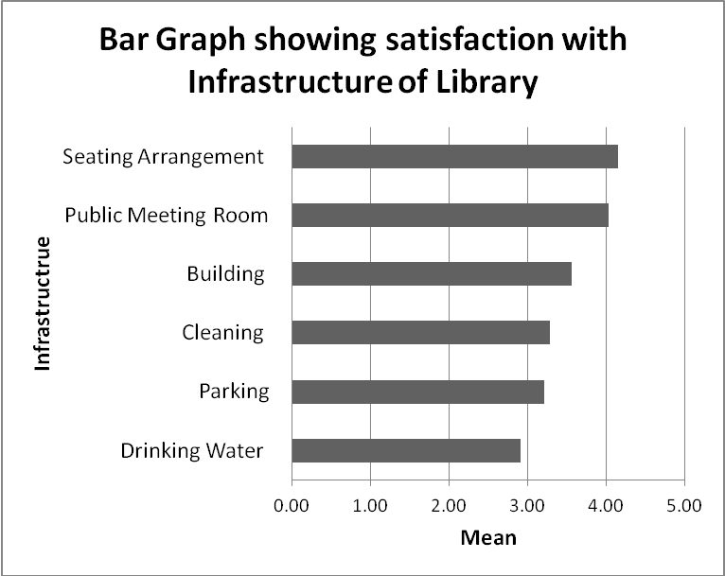
Figure 1 shows that users are highly satisfied with seating arrangement which has highest mean value i.e. 4.15 whereas users are least satisfied with facility of Drinking water which has least mean value i.e. 2.9.

Figure 2- BAR GRAPH SHOWING SATISFACTION WITH LIBRARY STAFF

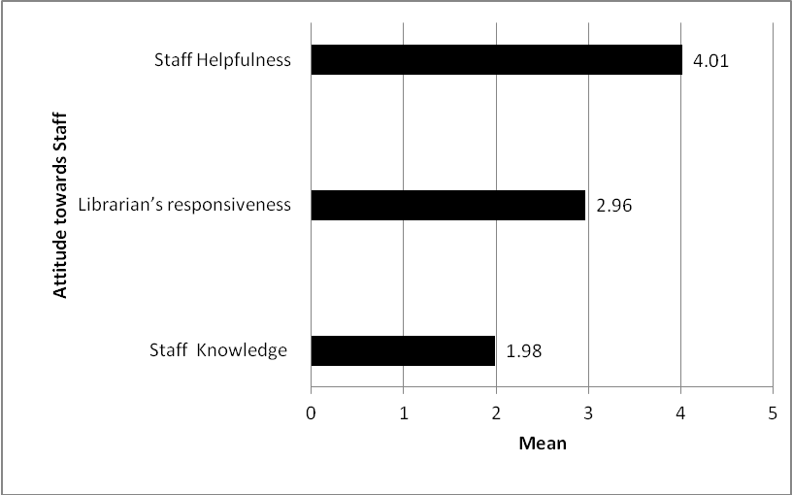

Figure 2 indicates that users are highly satisfied with helpfulness of staff whereas users are least satisfied with knowledge of staff with its least mean value i.e. 1.98.

Table 5- SATISFACTION WITH FACILITIES AND SERVICES

Facilities/services | Very Dissatisfied | Dissatisfied | Neutral | Satisfied | Very Satisfied | Total | Mean | Std. Dev. | Rank
Opening Hour | 6 | 19 | 8 | 31 | 18 | 82 | 3.44 | 1.268 | 1
 | 7.3 | 23.2 | 9.8 | 37.8 | 22.0 | 100.0
Circulation | 6 | 27 | 11 | 18 | 20 | 82 | 3.23 | 1.336 | 2
 | 7.3 | 32.9 | 13.4 | 22.0 | 24.4 | 100.0
Library Catalogue | 6 | 23 | 14 | 28 | 11 | 82 | 3.18 | 1.198 | 3
 | 7.3 | 28.0 | 17.1 | 34.1 | 13.4 | 100.0
Reservation of Books | 5 | 26 | 15 | 22 | 14 | 82 | 3.17 | 1.225 | 4
 | 6.1 | 31.7 | 18.3 | 26.8 | 17.1 | 100.0
Scanning Documents | 3 | 31 | 10 | 35 | 3 | 82 | 3.05 | 1.053 | 5
 | 3.7 | 37.8 | 12.2 | 42.7 | 3.7 | 100.0
OPAC (Online Public Access Catalogue | 19 | 20 | 0 | 32 | 11 | 82 | 2.95 | 1.456 | 6
 | 23.2 | 24.4 | 0 | 39.0 | 13.4 | 100.0
Workshops and Activities | 21 | 28 | 6 | 24 | 3 | 82 | 2.51 | 1.259 | 7
 | 25.6 | 34.1 | 7.3 | 29.3 | 3.7 | 100.0
Reference Service | 7 | 15 | 0 | 34 | 26 | 82 | 1.89 | .685 | 8
 | 8.5 | 18.3 | 0 | 41.5 | 31.7 | 100.0
Internet Access | 82 | 0 | 0 | 0 | 0 | 0 | 1.00 | .000 | 9
 | 100.0 | .0 | 0 | .0 | .0 | .0
Availability of Computers | 82 | 0 | 0 | 0 | 0 | 0 | 1.00 | .000 | 10
 | 100.0 | .0 | 0 | .0 | .0 | .0

Table 5 shows that highest number of users i.e. 31 (37.8%) are very satisfied with the opening hours of the library which has been ranked at 1st with the mean values (=3.44& σ=1.268) followed by circulation which has been ranked 2nd with mean values (=3.23 & σ=1.336). But the users of the library are very dissatisfied with availability of facility/service of internet and computers in the library which have been ranked in last i.e 9th and 10th respectively.

Table 6- MEAN DIFFERENCE OF USERS’ PERCEPTIONS ABOUT INFRASTRUCTURE, STAFF, FACILITIES AND SERVICES

Infrastructure | Student | 43 | 3.4767 | .68870 | .761 | .554
 | Housewives | 15 | 3.6778 | .46062
 | Professionals/Businessmen | 7 | 3.6905 | .32530
 | Retired | 5 | 3.2333 | .36515
 | Unemployed | 12 | 3.5556 | .53811
 | Total | 82 | 3.5285 | .59132
Staff | Student | 43 | 2.6357 | .59010 | .155 | .960
 | Housewives | 15 | 2.6444 | .52654
 | Professionals/Businessmen | 7 | 2.7619 | .16265
 | Retired | 5 | 2.6667 | .78174
 | Unemployed | 12 | 2.7500 | .53418
 | Total | 82 | 2.6667 | .54935
Facilities and Services | Student | 43 | 2.6047 | .37744 | .966 | .431
 | Housewives | 15 | 2.7077 | .42849
 | Professionals/Businessmen | 7 | 2.7802 | .27531
 | Retired | 5 | 2.8000 | .64036
 | Unemployed | 12 | 2.8205 | .42556
 | Total | 82 | 2.6820 | .40484
Overall | Student | 43 | 3.1063 | .27108 | .682 | .607
 | Housewives | 15 | 3.1287 | .21976
 | Professionals/Businessmen | 7 | 3.1945 | .18758
 | Retired | 5 | 2.9568 | .40067
 | Unemployed | 12 | 3.0580 | .30635
 | Total | 82 | 3.1018 | .26869

It has been observed from the above table 6 that there is no significant difference in the degree of satisfaction among different type of users regarding the Infrastructure, Staff, facilities and services because p value is more than the critical value (.05) in the each category. Hence, the hypotheses 4,5, and 6 are accepted.

As far as concerned with the overall satisfaction with the library, there has also not been observed significant difference among different type of users. The p value is more than the critical value (.05). Hence, the hypothesis 7 is also accepted. The above table shows that overall Professionals/Businessmen have more perception scores (mean =3.1945) with regard to satisfaction of overall library services. The users under the category of retired persons have least satisfaction with the overall library services.
Summary of the Findings:
- Majority of the respondents belong to the category of Students (52.4%).
- Majority of the respondents i.e. 78.05% visit the library daily.
- Majority of users always use library for reading ‘Magazines/Newspapers’, which has been ranked at Rank 1st followed by 'Borrow and Return the books' (2nd rank).
- Majority of the users i.e. 75.6% are highly satisfied with collection of Newspapers (=4.73) followed by Current Magazines (=4.2).
- The significant difference observed among users regarding collection. The highest mean perceptions score is of students is 3.7082 whereas of unemployed is 3.1061 showing the unemployed persons are least satisfied with library collection.
- Users are highly satisfied with seating arrangement (Rank 1st) whereas users are least with facility of Drinking Water (Rank 6th ).
- Users are highly satisfied with helpfulness of staff whereas users are least satisfied with knowledge of staff.
- Highest number of users i.e. 31 (37.8%) are very satisfied with the opening hours of the library which has been ranked at 1st followed by circulation which has been ranked 2nd.
- Users of the library are very dissatisfied with availability of facility/service of internet and computers in the library which have been ranked in last i.e 9th and 10th respectively.
- Professionals/Businessmen are highly satisfied with overall library infrastructure, staff, facilities and services with more perception scores (mean =3.1945) whereas the users under the category of retired persons have least satisfaction.
Suggestions
Based on the findings and observations, the suggestions are:
- There is need to improve collection of Audio/ Video and periodicals. Besides this collection of e-books is required to be added.
- To attract more information seekers and users, there is need to provide facility of internet and computer lab needs to be established.
Times New roman, 10, Justified
Times New roman, 10, Justified
- Facilities and services like Scanner, Printing and Photocopy should be added.
- There is immediate need to improve the facility of drinking water.
Times New roman, 12, Bold, Left
Times New roman, 12, Bold, Left
Times New roman, 12, Bold, Left
Conclusion
From the present study, it is concluded that among the respondents, students are highly satisfied with overall library collection. Retired persons are less satisfied with the library services as compared with other users. Since the environment is changing with the advancements and innovations of ICT infrastructure, the govt. should support for ICT Infrastructure. Besides this Govt. should make efforts to get the Haryana Public library Act implemented in toto.

REFERENCES
- Alden, C. "Libraries begin uncertain new chapter." Last modified 2006. http://books.guardian.co.uk/departments/referenceandlanguages/story/0,1715274,00.html.
Times New roman, 12, Bold, Left
- "Certified Public Library Administrator Program." ALA-APA | American Library Association-Allied Professional Association. Accessed March 23, 2014. http://ala-apa.org/certification/application/definition-of-a-public-library/.
- Chowdhury, Gobinda, Alan Poulter, and David McMenemy. "Public Library 2.0: Towards a New Mission for Public Libraries as a ?Network of Community Knowledge"." Online Information Review 30, no. 4 (June 2006): 454 ? 460. Accessed March 3, 2015. http://www.emeraldinsight.com/doi/pdfplus/10.1108/14684520610686328.
- Chowdhury, Gobinda, Alan Poulter, and David McMenemy. "Public Library 2.0: Towards a New Mission for Public Libraries as a ?Network of Community Knowledge"." Online Information Review 30, no. 4 (June 2006): 454 ? 460. Accessed March 3, 2015. http://www.emeraldinsight.com/doi/pdfplus/10.1108/14684520610686328.
- Iwhiwhu, Basil Enemute, and Patience Obotayire Okorodudu. "Public Library Information Resources, Facilities,and Services: User Satisfaction with the Edo State Central Library, Benin-City, Nigeria." Library Philosophy and Practice (e-journal), January 2012, 1-16. http://digitalcommons.unl.edu/cgi/viewcontent.cgi?article=1821&context=libphilprac.
Times New roman, 10, Justified
Times New roman, 10, Justified
Times New roman, 10, Justified
- Kumar, K., Doraswamy Naick, and D. Chandran. "Usage of Information Resources and Services in Zilla Granthalaya Samstha, Chitoor District(AP)." In 56th National Conference of ILA on Public Libraries of the Future: Opportunities and Challenges. New Delhi: Indian Library Association, 2011.
- Kumar, S.Kishore, and Lokesh Naik. "Use Pattern of Information Resources by Citizens in Public Library: A Case Study of District Central Library, Tumkur (Karnataka)." International Journal of Library and Information Studies 4, no. 4 (2014): 17-24. Accessed April 14, 2014. https://www.academia.edu/9067417/USE_PATTERN_OF_INFORMATION_RESOURCES_BY_CITIZENS_IN_PUBLIC_LIBRARY_A_CASE_STUDY_OF_DISTRICT_CENTRAL_LIBRARY_TUMKUR_KARNATAKA.
- "National Library of India." Ministry of Culture, Govt. of India. Accessed February 24, 2015. http://www.indiaculture.nic.in/national-library-india.
- "Public Library." Wikipedia, the Free Encyclopedia. Last modified March 30, 2015. http://en.wikipedia.org/wiki/Public_library.
- Thanuskodi, S. "Assessing the Efficacy of Library Services of District Central Libraries in Tamil Nadu from Users Perception." DESIDOC Journal of Library & Information Technology 32, no. 6 (2013): 485-492. http://publications.drdo.gov.in/ojs/index.php/djlit/article/view/2845.
- Velmurugan, V.Senthur. "Use of Library Sources and Services of Virudhunagar District Central Library -A Survey Study." e-Library Science Research Journal 2, no. 1 (2013): 17. Accessed March 12, 2104. http://www.lsrj.in/UploadedArticles/143.pdf.
- Woodsworth, Anne, and W. David Penniman, eds. Advances in Librarianship; Vol. 35: Context for Assessment and Outcome Evaluation in Librarianship. New York: Emrald, 2012.
- Yuvaraj, Mayank, and Ambrish Kumar Maurya. "Public Libraries in Varanasi (Uttar Pradesh), India:An Explorative Study." Library Philosophy and Practice (e-journal), 2014. Accessed March 12, 2015. http://digitalcommons.unl.edu/cgi/viewcontent.cgi?article=3092&context=libphilprac.

